DPTC Tournaments 2022 - Rules of Play

- You must pay your entry fee(s) before you play any matches. Sign up and pay online using you tennisbookings account (under Events). The signup fee is $10 per player per tournament.

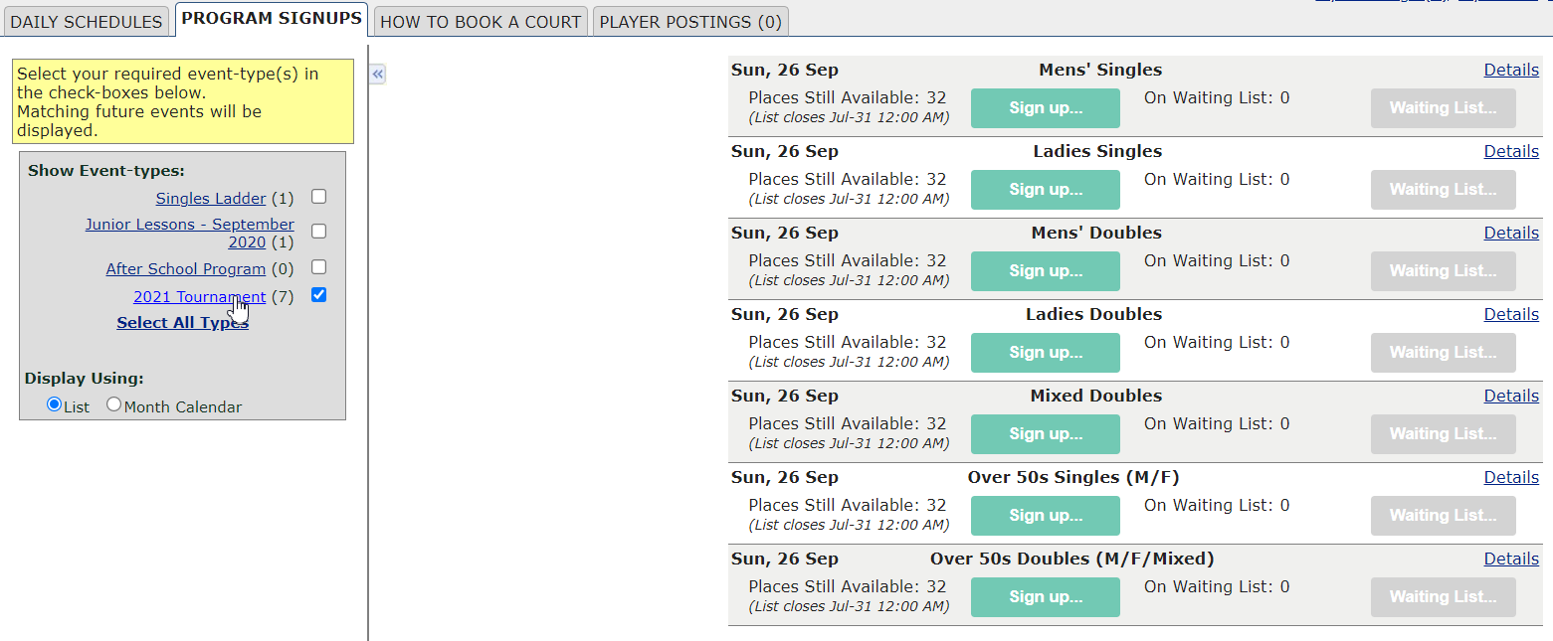

- Categories for signup are Men’s singles, Ladies’ singles, Men’s doubles, Ladies’ doubles, Mixed doubles, over 50s singles and over 50s doubles.

- Players are guaranteed two matches. If you lose in the first round you go into a consolation draw.

- Tournament matches must be completed within one hour. The format is one pro set, first to win 8 games, no-ad scoring. Keep the warm-up short, maximum ten minutes.

- Players should normally not attempt to play a match during public hours. You cannot keep the court for more than half an hour (singles or doubles) if people are waiting. That’s the rule for public hours.

- Players are to arrange their own matches.Tournament match bookings will count in players’ seven day booking windows.Tournament matches can be scheduled anytime in regular bookable timeslots.

- A tournament will be round-robin format if fewer than 8 players/doubles pairs have entered.
- If a tournament is a round-robin format the player/doubles pair with the most matches won will be the winners of the tournament. If there’s a tie based on matches won, the most games won will be used to break the tie.

- The tournament coordinator will set 10 day deadlines for each round to make sure matches are completed within a reasonable timeframe. All matches must be completed by the deadlines set, no exceptions.

- Play with new or used balls, to be agreed by the players. One approach is for each player/team to bring a new can of balls. Play with one can and the winners get to keep the new can – the loser gets the used balls.

- New balls will be provided by the club for the Final matches.

- If you have questions email DPTCTournaments@gmail.com

